PART A
1.Website Specifications
Objective of the website:
The website created is an e-commerce website called FashionHub. Its objective is to bring convenience to the customer by providing a digital platform that enables the buying of goods through the internet. This website is not only convenient but also efficient as it uses easy user interface to communicate with the customer.
Goals in relation to business:
- Global market accessibility: “E-commerce transcends geographical boundaries, enabling businesses to reach global markets with unprecedented ease” (Amin, 2021). FashionHub is available at any time and allows customers to browse for the collection wherever they are.
- Building trust in e-commerce. According to Quintus, Mayr, Hofer and Chiu (2024) the trust of a customer to a digital platform is importance for its success. FashionHub builds this trust by delivering high quality products that match the description and images displaying the product. This is to allow people to change their opinion and build confidence in shopping online through digital platforms.
- Creation of revenue. FashionHub creates revenue through selling products online. Since FashionHub is a digital platform that operates 24/7 meaning it also helps to increase the revenue as customers/users can buy products at anytime.
b) Target audience and their demographics
The FashionHub website is created so that all genders (females and males) can be use it, young adults (45-20), teenagers (19-13) and children (12 and below) as the collection on the website caters for them all. Since FashionHub is a digital platform, it means that the customers are in different parts of the world.
Technical aptitude
The FashionHub target audience has varying technical aptitude. Children (12 and below) have limited digital literacy resulting in the need of an adult to assist them with using the website. Teenagers (13-19) and young adults (20-45) have an excellent/advanced digital literacy making it easier for them to navigate and use the website.
Information Design & Taxonomy
FashionHub Site Map
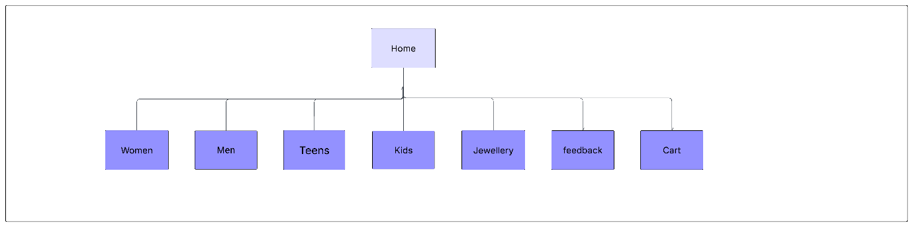

Storyboard flowchart
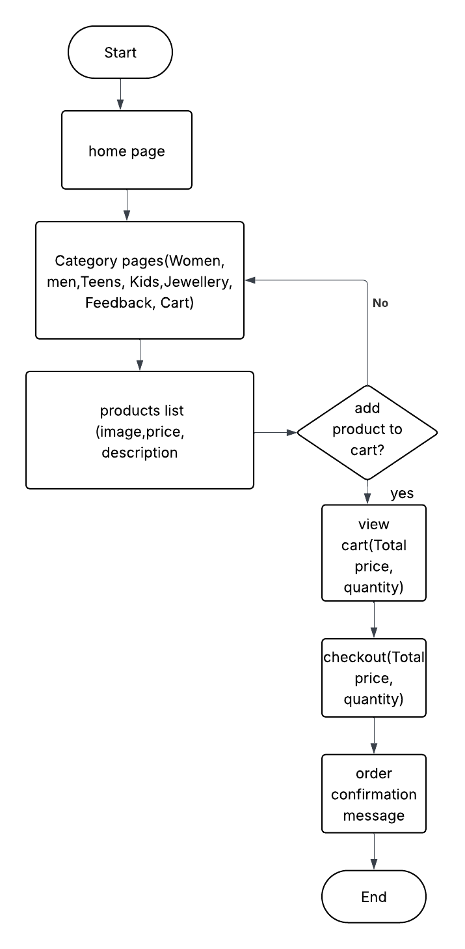
Technical brief
I used different tools to create the website.
Software tools used:
- Visual studio code - development and coding
- GitHub pages - collaboration and website publishing
Languages used:
- Hypertext markup language (Html5)- for structure and layout of the website.
- JavaScript- used for interactive features like “Add to cart”.
- Cascading style sheets (CSS3)- for styling the website.
Graphical tools used:
- Canva – to show how the complete website is to look.
- Lucid chart- to create storyboard, wireframes and site map that is used to show the structure and layout of the website. It is also used to show the navigation bar.
Other resources used:
- Pinterest and Google – to get images that are used on the website.
- Material design colours website- to help with colour combination for the website.
- Bootstrap – used to make the FashionHub webpage responsive.

